**Detecting and Evaluating Fake News**

Ariyana Chatterjee,

BSc. Data Science (H),

St. Xavier’s College(Autonomous), Kolkata

Period of Internship: 25th August 2025 - 19th September 2025

Report submitted to: IDEAS – Institute of Data Engineering, Analytics and Science Foundation, ISI Kolkata

1. **Abstract**

This project takes up the difficult task of detecting the fake news and distinguishing it from the true news by applying machine learning techniques. Here, a classification model is trained on textual data, and the effectiveness is evaluated through a confusion matrix to assess accuracy and misclassification patterns.

1. **Introduction**

The given project- Detection and Evaluation of Fake News- is a part of the internship conducted by IDEAS – Institute of Data Engineering, Analytics and Science Foundation, ISI Kolkata from 25th August 2025 - 19th September 2025.

This project delves into the intricacies of machine learning by using testing models and Pandas DataFrame to perform test runs on 25% of the dataset to train the pattern of detection of fake news and distinguishing it from true news. Here, specifically a classification model is trained on textual data and the effectiveness is evaluated through a confusion matrix to assess accuracy and miscalculation patterns.

This project can make it easy for the internet to sieve out the fake news that would otherwise confuse the public and cause panic and chaos. It acts like an effective tool to segregate reality from propaganda.

The dataset used in the project was compiled from real-world sources; the genuine articles were scraped from Reuters.com (a reputable news website). In contrast, the fake news articles were gathered from various unreliable platforms identified by Politifact (a U.S.-based fact-checking organization) and Wikipedia. The collection covers articles on diverse subjects, though most of them center around politics and world news.

The dataset cab also be downloaded from Kaggle using the link: [www.kaggle.com/datasets/emineyetm/fake-news-detection-datasets](https://www.google.com/url?q=http%3A%2F%2Fwww.kaggle.com%2Fdatasets%2Femineyetm%2Ffake-news-detection-datasets)

Other than the project assigned, IDEAS, ISI also conducted a two-week training program which provided classes on the following topics:

1. Basics of Python
2. Using Functions, Classes in Python and Object-oriented Programming
3. Using Numpy and Pandas Dataframe
4. Custom data types and Magic Methods
5. Fundamentals of Machine Learning
6. Regression analysis
7. Neural networks and perceptron as basic models for Binary classification
8. Ollama
9. Communication Skill
10. **Project Objective**
11. The objective of this project is:

* To fully train a Machine Learning Model to detect, evaluate and distinguish fake news.
* To easily filter out the multiple eye- catching [meretricious news](https://www.google.com/search?client=firefox-b-d&cs=0&sca_esv=a1feb94103ceaa7e&sxsrf=AE3TifNkbDAuluNZbKbFebpmYUF9hsEQvQ%3A1758219707705&q=meretricious+news&sa=X&ved=2ahUKEwihpdro9uKPAxVU1TgGHY-4Hu4QxccNegQIAhAC&mstk=AUtExfD6cE0JR_doN8Ay6xamBLKKFwOZQJIJ3SDZ3ALbUmE-YktdmyEmBbZHJz8LJjLSwlOvrb9qomkj7P7DbAPWAcIp23_l-jcgKz6NYgiulXPvJVeVjY72Z1xd0Zfw-85yLLKFZjgYkgjrDdtTbGAdCzaOS5hF3NvUaXso9NviZfRbm_8&csui=3) or clickbait, which can easily sway the public in the wrong direction.
* To provide only the reality to the people.

1. It uses several common packages like numpy, pandas, matplotlib.pyplot to form different Dataframes and show several diagrammatic representations of the different categories of the dataset provided.
2. This project essentially trains a classification model to use a confusion to learn a pattern.
3. It divided the data into 2 parts, taking 25% of the data for training purposes.
4. **Methodology**

The project was given in a Question- Answer form, which tested the basic knowledge acquired during the 2-week training program. Here, it combined machine learning concepts with the Python Pandas module to create a training model which will read and detect fake news so that the same can be segregated from true news. Through this project, the aim was to build up the skills on Python and AI/ML tools.

The project uses two data sets, “true.csv” and “fake.csv”, to teach the classification model to assess textual data and evaluate the effectiveness using a confusion matrix to detect the accuracy and miscalculation patterns.

The dataset used in the project was compiled from real-world sources; the genuine articles were scraped from Reuters.com (a reputable news website). In contrast, the fake news articles were gathered from various unreliable platforms identified by Politifact (a U.S.-based fact-checking organization) and Wikipedia. The collection covers articles on diverse subjects, though most of them center around politics and world news.

The packages used were:

1. matplotlib.pyplot
2. pandas
3. numpy
4. seaborn
5. re
6. string
7. sklearn model
8. genism model

The following steps were taken:

1. Importing packages
2. Data Preprocessing
3. Data Visualisation
4. Text Processing
5. Model Building
6. Word Embedding (Word2Vec)
7. Logistic Regression
8. Accuracy Checking
9. Working with Random Forest Classifier
   1. Model Building and Prediction
   2. Accuracy Checking
10. Saving the Model using Pickle

At first, the two csv files were fully read and stored in variables. Then the data was preprocessed by dropping the rows containing null values. Then the categorical data was represented into two diagrams- A bar graph and a pie diagram. The text was then processed such that it was all in lower case, ‘https:// and [www.com](http://www.com)’, special characters and multiple spaces were removed. Further the unnecessary columns were dropped. Then, the training model was built.

The data was separated according to the independent and target columns and stored in variables x and y. This data was then split into training and training sets with a 25% test size and stored in 4 variables x_train, x_test, y_train and y_test.

A function was used to convert the sentence to a vector for easy processing. Then, a logistic regression model was trained to use vector formed trained data. This was applied to the data and a prediction of truth vs fake was performed. The accuracy of the same was evaluated.

Random Forest Classifier was used for Model building and Prediction. This helped in the classification purpose and predicting the outcomes for test data. The accuracy of the same was also evaluated. Finally, the model was saved using the pickle module and the saved model was loaded into another Notebook to use on other dataset for fake news detection.

The project was conducted on Google Colab.

The link for the same is:

https://github.com/AriyanaC/Internship-project--IDEAS-Institute-of-Data-Engineering-Analytics-and-Science-Foundation-ISI-Kolkata/blob/main/04_fake_news_detection_and_evaluation.ipynb

1. **Data Analysis and Results**

**Summary of Findings and Results**

The key findings from the fake news detection project, including descriptive analysis, inferential analysis, and a comparative analysis of the machine learning models used is described below.

**Descriptive Analysis**

The dataset consists of fake and true news articles with the following columns: title, text, subject, and date. After loading and preprocessing the data (dropping null values, shuffling, and resetting index), the dataset was ready for analysis.

The distribution of news articles across different subjects was visualized using a pie chart, showing the percentage of news in each category. A bar chart also highlighted the top 5 subjects in the dataset.

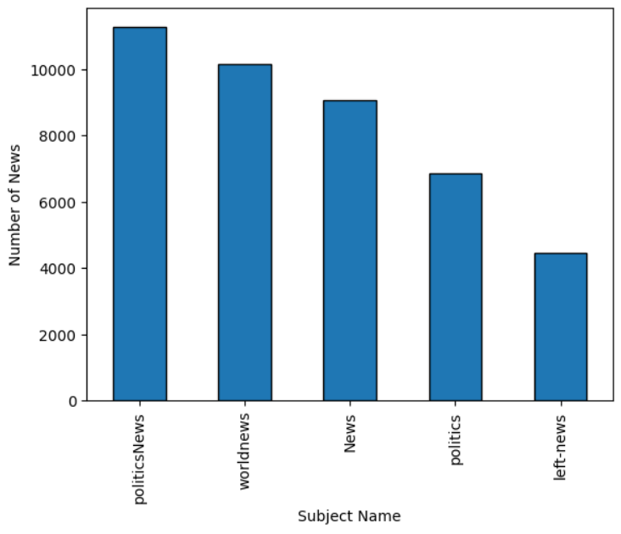

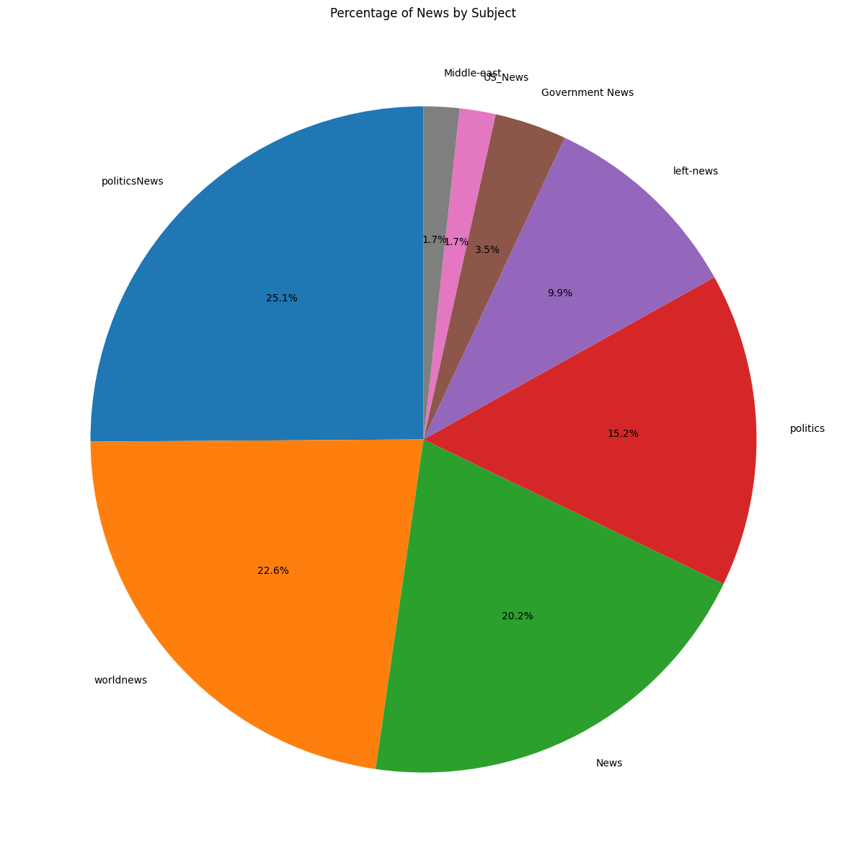

* **Top 5 Subjects:**
  + politicsNews
  + worldnews
  + News
  + politics
  + left-news

**Inferential Analysis**

The project infers the effectiveness of the machine learning models in classifying fake and true news based on their performance metrics. The goal is to determine if the models can reliably distinguish between the two classes.

**Machine Learning Model Comparative Analysis**

Two machine learning models, Logistic Regression and Random Forest Classifier, were trained and evaluated for the fake news detection task. Both models used Word2Vec for text vectorization. The performance of each model was assessed using accuracy, precision, recall, and F1-score, and visualized with a confusion matrix.

Here is a comparative summary of the model performance:

| **Metric** | **Logistic Regression** | **Random Forest Classifier** |
| --- | --- | --- |
| Accuracy | 0.9427 | 0.9431 |
| Precision | 0.9506 | 0.9496 |
| Recall | 0.9405 | 0.9422 |
| F1 Score | 0.9455 | 0.9459 |

**Confusion Matrix**

The confusion matrices for both models visually represent the true positives, true negatives, false positives, and false negatives.

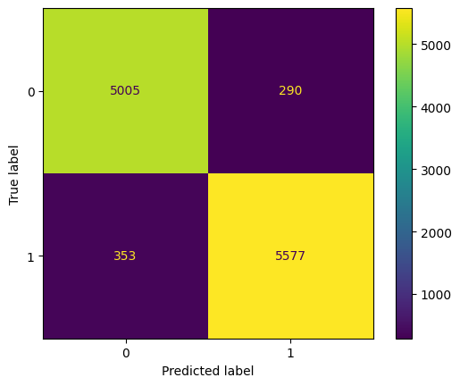 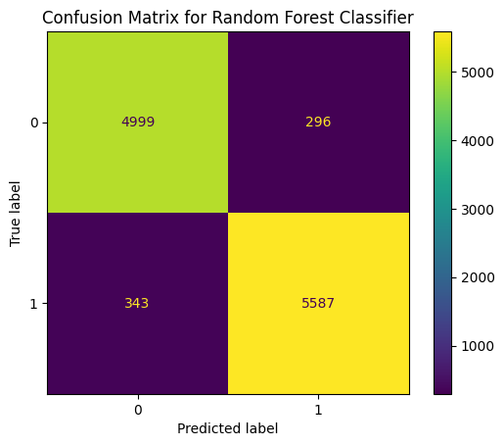

**Model Saving and Loading**

Both the Logistic Regression and Random Forest models were successfully saved using pickle for future use. The saved Random Forest model was loaded and used to make predictions on a new dataset, demonstrating the ability to deploy the trained model.

1. **Conclusion**

Through the project, we were able establish a comprehensive training model with a relatively high degree of accuracy. We were successfully able to form visual graphs to show the categorical distribution of the given data. Further, a strong detecting tool was effectively set up in the process.

1. **APPENDICES**

You may create separate Appendix for the following:

1. W3Schools (Papers, Journals, Websites etc. needed to be referred for your project)
2. <https://github.com/AriyanaC/Internship-project--IDEAS-Institute-of-Data-Engineering-Analytics-and-Science-Foundation-ISI-Kolkata/tree/main>
3. <https://colab.research.google.com/drive/1X7UgYg3_UCMT6gdVuZl1nH5MmrXJ1Sz_#scrollTo=DEuVqu0P7KnJ>